Question I [6 pts]
Consider the transmission of digital images with a resolution of 720×576. If we use a 2 Mbit/s transmission channel, answer the following:
- Considering that the transmission channel is available during 10 s, how many complete black and white images can be transmitted without any compression?
- How many complete grey scale images can be transmitted, in the same 10 s, if images with 256 grey levels are used?
- Consider now 24-bit colored images with a 4:2:0 subsampling schema., how many complete images can be transmitted still in the same 10 s?
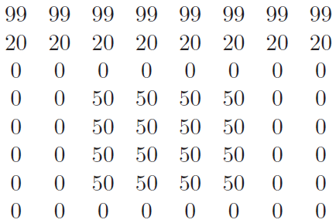
Question II [12 pts]
Given the following piece of a grayscale image that we want to compress, answer the following:

- What is the entropy of the image?
- If no compression is used, how many bits is needed to encode each pixel? and what is the efficiency of this coding?
- Apply the RLE compression method and calculate the size of the compressed image.
- Construct the Huffman tree to encode the above image.
- Calculate the average bits per pixel and the efficiency of your codes.
- Suppose now that we want to quantize the image in which each pixel will be coded on 2 bits instead of 8.
  - What is the resultant image? and its entropy?
  - Construct new Huffman codes, calculate the average bits per pixel and the efficiency of the codes.
Question III [6 pts]
- Suppose we have the following alphabet of symbols {a, b, c}. Using the ASCII code of each symbol (a is 97, b is 98, c is 99), compress the message “a b b a c c c a b c” using the LZW algorithm.

- Decode the following message 97 98 256 97 99 259 97.
Question IV [6 pts]
Given the below piece of image, apply the Floyd-Steinberg algorithm for dithering (error-diffusion method) in order to transform the piece of image into a black and white image.

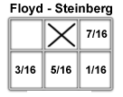
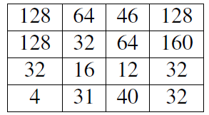
Piece of image for dithering

Error distribution schema

